**Scott Anderson**

**CSD325-T301**

**Module 7.2 Assignment**

**07/08/2025**

**Initial Output**

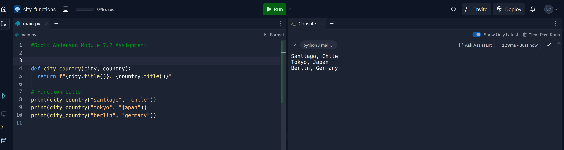

**city and country**

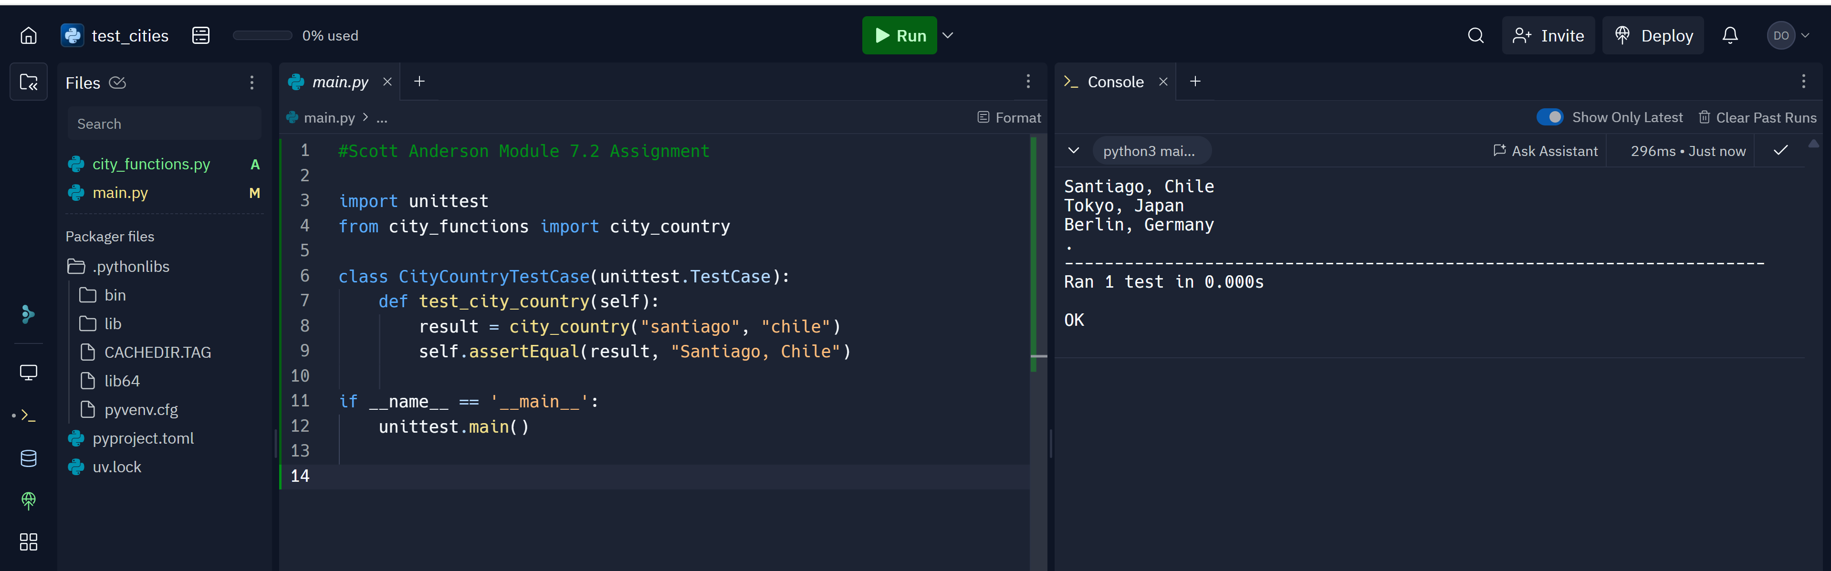

**Population added and test fail**

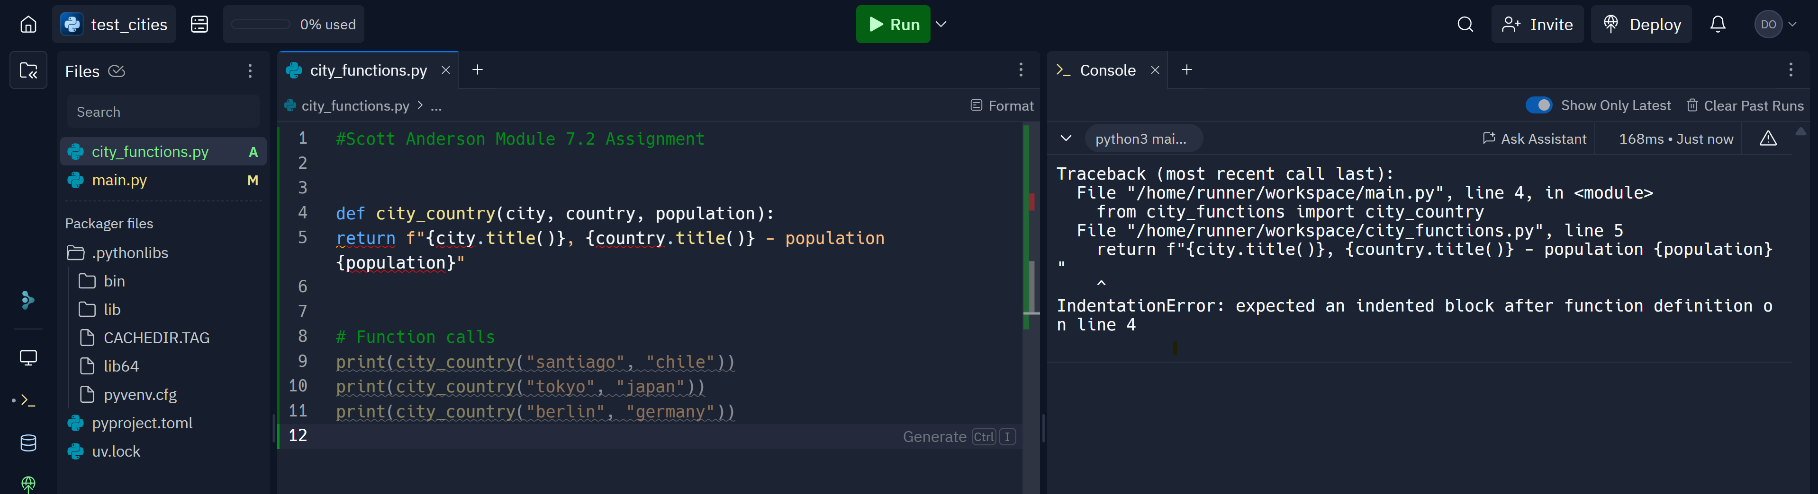

**population optional test pass**

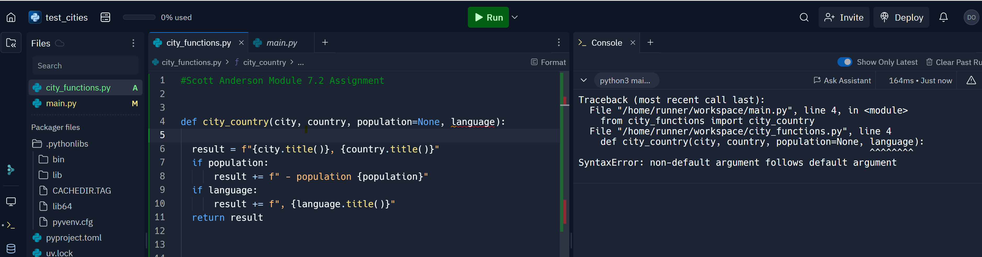

**language required test fail**

